**Market Segmentation Using Machine Learning**

*A project report submitted in*

*The partial fulfilment of the requirements for the award of the*

*degree of*

###### Bachelor of Technology in Computer Science & Systems Engineering

**R.SAI ROSHINI P.HARSHITHA VARMA G.AISHWARYA M.RAM**

Submitted by

**(19KD1A1552) (19KD1A1549) (19KD1A1521) (19KD1A1541)**

Under the guidance of

Mrs. V.ANUPAMA

**Associate Professor**

**Department of CSIT**



###### Department of Computer Science & Engineering

**LENDI INSTITUTE OF ENGINEERING & TECHNOLOGY**

An Autonomous Institution, Accredited by NBA & NAAC with “A” Grade Permanently Affiliated to JNTUK, Approved by

A.I.C.T.E, Jonnada, Vizianagaram

Dist.535005.

2019-2022

pg 1



**Permanently Affiliated to JNTUK, Approvedby**

**A.I.C.T.E, Jonnada, Vizianagaram Dist - 535005.**

**NBA**

**LENDI INSTITUTE OF ENGINEERING**

**&TECHNOLOGY**

**AN AUTONOMOUS INSTITUTION**

**Accredited by NAAC with “A” Grade, Accredited by**

##### DEPARTMENT OF COMPUTERSCIENCE AND ENGINEERING

**BONAFIDE CERTIFICATE**

This is to certify that the project entitled “**Market Segmentation Using Machine Learning”** is a Bonafide record of the work done by **R. Sai Roshini (19KD1A1552), P. Harshitha Varma (19KD1A1549), G. Aishwarya (19KD1A1521), M. Ram (19KD1A1541)** under the supervision and guidance of **Mrs.V.Anupama, Associate Professor** in partial fulfilment of the requirements for the award of the degree of Bachelor of Technology in Computer Science and Engineering from Lendi Institute of Engineering and Technology (Affiliated to JNTUK), Jonnada, Vizianagaram for the year 2023.

Internal Guide

**Mrs.V.Anupama**

**Associate Professor Department of CSIT**

Head of the Department

###### Dr. R. Rajendra

**Department of CSSE**

**External Examiner**

## ACKNOWLEDGEMENT

With great solemnity and sincerity, we express our deepest sense of gratitude and pay our sincere thanks to our guide **Mrs V. Anupama, Associate Professor, Department** of CSIT, who evinced keen interest in our efforts and provided valuable guidance throughout our project work.

We thank **Prof. R. Rajendra, Head of the Department of Computer Science & Systems Engineering**, who helped us to complete our project work in a truthful method.

We thank our **Mr S.Swaroop, Assistant Professor of Computer Science & Systems** Engineering, who helped us to complete our project work in a truthful method. We thank our gratitude to our **principal Dr V.V. Rama Reddy,** for his kind attention and valuable guidance to us throughout this course in carrying out the project. We wish to express gratitude to our Management Members who supported us in providing good lab facilities. We are thankful to All Staff Members of the **Department of Computer Science & Systems Engineering,** for helping us directly / indirectly to complete this project work by giving valuable suggestions. All the above we greatly fully acknowledge and express our thanks to our parents who have been instrumental in the success of this project which plays a vital role.

**R. SAI ROSHINI P.HARSHITHAVARMA**

**G. AISHWARYA**

###### M. RAM

(19KD1A1552) (19KD1A1549) (19KD1A1521) (19KD1A1541)

**DECLARATION**

We hereby declare that the project work entitled **“Market Segmentation Using Machine Learning"** submitted to the JNTU Kakinada is a record of an original work done by **R. Sai Roshini (19KD1A1552), P. Harshitha Varma (19KD1A1549), G. Aishwarya (19KD1A1521), M. Ram (19KD1A1541)** under the esteemed guidance of

**Mrs V. Anupama, Associate Professor, Computer Science & Information Engineering, Lendi Institute of Engineering & Technology.** This project work is submitted in the partial fulfilment of the requirements for the award of the Bachelor of Technology in Computer Science & Systems Engineering. This entire project is done to the best of our knowledge and is not submitted to any University for the award of degree.

**R. SAI ROSHINI**

**P. HARSHITHA VARMA**

G. AISHWARYA

**M. RAM**

(19KD1A1552) (19KD1A1549) (19KD1A1521) (19KD1A1541)



LENDI INSTITUTE OF ENGINEERING &TECHNOLOGY AN AUTONOMOUS INSTITUTION

**Accredited by NAAC with “A” Grade, Accredited by NBA** Permanently Affiliated to JNTUK, Approved by A.I.C.T.E, Jonnada, Vizianagaram Dist. - 535005.

**DEPARTMENT OF COMPUTER SCIENCE AND SYSTEMS ENGINEERING**

**VISION**

To be a frontier in computing technologies to produce globally competent computer science engineering graduates with moral values to build a vibrant society and nation.

**MISSION**

Providing a strong theoretical and practical background in computer science engineering with an emphasis on software development.

Inculcating professional behavior, strong ethical values, innovative research capabilities, and leadership abilities.

Imparting the technical skills necessary for continued learning towards their professional growth and contribution to society and rural communities.

**PROGRAM EDUCATIONAL OBJECTIVES**

**(PEOs)**

**PEO-1:** Graduates will have strong knowledge and skills to comprehend the latest tools and techniques of Computer Engineering so that they can analyze, design a create computing products and solutions for real life problems.

**PEO-2:** Graduates shall have multidisciplinary approach, professional attitude and ethics, communication and teamwork skills, and an ability to relate and solve social issues through their Employment, Higher Studies and Research.

**PEO-3:** Graduates will engage in life-long learning and professional development to adapt to rapidly changing technology.

**PROGRAM SPECIFIC OUTCOMES (PSOs)**

**PSO-1:** Ability to grasp advanced programming techniques to solve contemporary issues.

**PSO-2:** Have knowledge and expertise to analyse data and networks using latest tools and technologies.

**PSO-3:** Qualify in national and international competitive examinations for successful higher studies and employment.

**PROGRAM OUTCOMES (POS)**

**PO-1** Engineering Knowledge: Apply the knowledge of mathematics, science, engineering fundamentals, and an engineering specialization to the solution of complex engineering problems.

**PO-2** Problem Analysis: Identify, formulate, review research literature, and analyze complex engineering problems reaching substantiated conclusions using first principles of mathematics, natural sciences, and engineering sciences.

**PO-3** Design/development of Solutions: Design solutions for complex engineering problems and design system components or processes that meet the specified needs with appropriate consideration for the public health and safety, and the cultural, societal, and environmental considerations

**PO-4** Conduct Investigations of Complex Problems: Use research-based knowledge and research methods including design of experiments, analysis and interpretation of data, and synthesis of the information to provide valid conclusions.

**PO-5** Modern Tool Usage: Create, select, and apply appropriate techniques, resources,

and modern engineering and IT tools including prediction and modelling to

complex

engineering activities with an understanding of the limitations.

**PO-6** The Engineer and Society: Apply reasoning informed by contextual knowledge

to assess societal, health, safety, legal and cultural issues and the consequent responsibilities relevant to the professional engineering practice.

pg. 6

**PO-7** Environment and Sustainability: Understand the impact of professional engineering solutions in societal and environmental contexts, and demonstrate the knowledge of, and need for sustainable development.

**PO-8** Ethics: Apply ethical principles and commit to professional ethics and responsibilities and norms of engineering practice.

**PO-9** Individual and Teamwork: Function effectively as an individual, and as a member or leader in diverse teams, and in multidisciplinary settings.

**PO-10** Communication: Communicate effectively on complex engineering activities with the engineering community and with society at large, such as, being able to comprehend and write effective reports and design documentation, make effective presentations, and give and receive clear instructions.

**PO-11** Project Management and Finance: Demonstrate knowledge and understanding of the engineering and management principles and apply these to one’s own work, as a member and leader in a team, to manage projects and in multidisciplinary environments.

**PO-12** Life-Long Learning: Recognize the need for and have the preparation and ability to engage in independent and life-long learning in the broadest context of technological change.

**ABSTRACT**

Effective decisions are mandatory for any company to generate good revenue. In these days competition is huge and all companies are moving forward with their own different strategies. We should use data and take a proper decision. Every person is different from one another and we don’t know what he/she buys or what their likes are. But, with the help of machine learning technique one can sort out the data and can find the target group by applying several algorithms to the dataset. Without this, It will be very difficult and no better techniques are available to find the group of people with similar character and interests in a large dataset. Here, The customer segmentation using K- Means clustering helps to group the data with same attributes which exactly helps to business the best. We are going to use elbow method to find the number of clusters and at last we visualize the data. Market Segmentation is thea process of dividing customers into groups based on common characteristics so companies can market to each group effectively and appropriately. Customers are segmented according to their similarities in behaviour and habits. Our goal is to segment their customers given the customer’s various behaviors and features, in order for the company to be able to market for each segment in a manner that is more fitting to each individual customer. Market Segmentation is one the most important applications of unsupervised learning. Using clustering techniques, companies can identify the several segments of customers allowing them to target the potential user base. In this machine learning project, we will make use of K-means clustering which is the essential algorithm for clustering unlabeled dataset.Main objective is to develop a Customer Segmentation to give recommendations like saving plans, loans, wealth management on target groups. Finally we will create a streamlit application based on the clustering technique, where we are taking the customer details and identifying which cluster the customer belongs to.

Keywords- Telecome Retention, Churn Analysis , Exploratory Data Analysis, Telecustomer Dataset

**Outcomes:**

**Our project titled**

***“ Market segmentation*”**

is mapped with the following outcomes:

**Program Outcomes : P01,PO2,PO3,PO4,PO5,PO6,PO7,PO8**

**Program Specific Outcomes : PSO1, PSO2, PSO3.**

LIST OF CONTENTS

Title Page No

|  |  |  |
| --- | --- | --- |
| S No | INTRODUCTION |  |
| 1  2 | 1.1 Project Overview |  |
| 1.2 Project Deliverables |  |
| 1.3 Project Scope |  |
| LITERATURE |  |
|  | SURVEY PROBLEM |  |
| 3 | ANALYSIS |  |
| 3.1 Existing System |  |
| 3.1.1 Challenges |  |
| 3.2 Proposed System |  |
| 3.2.1 Advantages |  |
| 4 | SYSTEM ANALYSIS |  |
| 4.1 Software Requirement Specification |  |
| 4.1.1 Functional Requirements |  |
| 4.1.2 Non - Functional Requirements |  |
| 4.2 Feasibility Study |  |
| 4.3 System Requirements |  |
| 4.3.1 Software Requirements |  |
| 4.3.2 Hardware Requirements |  |
| 5 | SYSTEM DESIGN |  |
| 5.1 Introduction |  |
| 5.1.1 System Architecture |  |
| 5.1.2 Use Case Diagram |  |
| 5.1.3 Class Diagram |  |
| 5.1.4 Component Diagram |  |
| 5.1.5 Deployment Diagram |  |
|  |  |

|  |  |  |
| --- | --- | --- |
| 6 | IMPLEMENTATION |  |
| 6.1 Algorithm Description | 43-57 |
| 6.2 Technology Description | 43 |
| 6.2.1 Python | 47 |
| 6.2.2 Jupyter ,Streamlit | 48 |
| 6.2.3 Html, Java script, CSS, jQuery | 49 |
| 6.3 Sample Source Code | 48 |
| 7 | TESTING | 54-57 |
| 7.1 Introduction | 59-66 |
| 7.2 Test Cases | 60 |
|  |  | 55 |
| 8 9 | RESULT | 58 |
| 10 | CONCLUSION | 68-71 |
| 11 | REFERENCES | 72-73 |
|  |  | 74-75 |

-

**LIST OF FIGURES**

|  |  |  |
| --- | --- | --- |
| **Fig No.** | Name | Page no |
| **1** | System Architecture | 30 |
| **2** | Use case Diagram | 31-32 |
| **3** | Activity Diagram | 33-35 |
| **4** | Class Diagram | 36-38 |
| **5** | Component Diagram | 39 |
| **6** | Deployment Diagram | 39-41 |

**CHAPTER 1**

**INTRODUCTION**

1.INTRODUCTION

Market segmentation is a marketing term that refers to aggregating prospective buyers into groups or segments with common needs and who respond similarly to a marketing action. Market segmentation enables companies to target different categories of consumers who perceive the [full value](https://www.investopedia.com/terms/f/full-value.asp) of certain products and services differently from one another. By arranging their company's target market into segmented groups, rather than targeting each potential customer individually, marketers can be more efficient with their time, money, and other resources than if they were targeting consumers on an individual level. Grouping similar consumers together allows marketers to target specific audiences in a cost-effective manner.

Market segmentation also reduces the risk of an unsuccessful or ineffective marketing campaign. When marketers divide a market based on key characteristics and personalize their strategies based on that information, there is a much higher chance of success than if they were to create a generic campaign and try to implement it across all segments. Market segmentation is the process of dividing a market of potential customers into groups, or segments, based on different characteristics. The segments created are composed of consumers who will respond similarly to marketing strategies and who share traits such as similar interests, needs, or locations. The market is composed of customers and sellers, and different customers may have different needs, characteristics, behaviour or buying attitudes. Each customer is a separate entity, they have unique wants. Therefore, sellers may divide a market into different groups of individual markets. Every consumer group is a market segment, each segment is the tendency of buyers with similar wants or needs. They divide the market into distinct groups that have distinct needs, wants, and behaviour or who might want different products and services. This action is known as marketing segmentation. The modern concept of market segmentation was put forward by Phillip Kotler, who states that market segmentation is the “sub-dividing of a market into homogenous subsets of customers, where any subset may be conceivably be selected as a market target to be reached with a distinct [marketing mix](https://www.mbaknol.com/marketing-management/marketing-mix-4-ps-of-marketing-mix/)“. It is a concept in economics and marketing. Marketing segmentation is marketers through market research, based on the wants and desires of customers, differences in their buying behaviour and purchasing habits, divide a whole market into a number of individual groups in the market classification process. Segmentation allows the wine company to better satisfy the needs of its customers. Company only through the market segmentation, select the most favourable market area in order to achieve economic profits. If more detailed to segmented market, it can be two parts, consumer market segmentation and business market segmentation. The modern concept of market segmentation was put forward by Phillip Kotler, who states that market segmentation is the “sub dividing of a market into homogenous subsets of customers, where any subset may be conceivably be selected as a market target to be reached with a distinct [marketing mix](https://www.mbaknol.com/marketing-management/marketing-mix-4-ps-of-marketing-mix/)“.

**pg. 13**

**Project Overview:**

Market segmentation is a marketing term that refers to aggregating prospective buyers into groups or segments with common needs and who respond similarly to a marketing action. Market segmentation enables companies to target different categories of consumers who perceive the [full value](https://www.investopedia.com/terms/f/full-value.asp) of certain products and services differently from one another.

###### Project Deliverables:

Market segmentation is a process that companies use to break their potential customers into different sections. This allows the company to allocate the appropriate resource to each individual segment which allows for more accurate targeting across a variety of marketing campaigns. By developing specific plans for specific products with target audiences in mind, a company can increase its chances of generating sales and being more efficient with resources.

**Project Scope:**

While defining a project scope may seem like a daunting task, it really comes down to two things; knowing you want to get out of your project, and deciding how you’re going to get it. It also helps to know some of the common language used to define market research studies. Read on to learn about a common project type: market segmentation.

pg. 14

CHAPTER 2

LITERATURE SURVEY

pg. 15

1. LITERATURE SURVEY

This section reviews papers based on market segmentation using machine learning techniques. Papers published in the last ten years are reviewed and analyzed based on the methodologies used.

[ 1 ] This research is written as the replication of study by Hans Ouwersloot, who is an Associate Professor of Marketing at Maastricht University, and Gaby Odekerken- Schröder, who is an Associate Professor in Marketing at Maastricht Customer Marketer Product Focal Customer Brand 20 University. The research title is “Who’s Who in Brand Communities and Why?”, written in 2008. The research aims to explore whether a community population can be meaningfully segmented on the basis of different motivations to join.

[ 2 ] Second, with the title “Building Brand Community” was written in 2002 by James H. McAlexander and Harold F. Koenig, who are the Associate Professors of Marketing, College of Business Administration, Oregon State University. John W. Schouten is Associate Professor of Marketing, School of Business Administration, and University of Portland. This research is about analyzing brand community through its crucial relationships; including those between the customer and the brand, between the customer and the firm, between the customer and the product in use, and among fellow customers and yields a deeper study from the previous research.

[ 3 ]The third journal written in 2002 by Albert M. Muniz, Jr and Thomas C. O’Guinn with the title “Brand Community”.This article introduces the idea of brand community, which exhibits three traditional markers of community: shared consciousness, rituals and traditions, and a sense of moral responsibility. Brand communities reveal the socially situated nature of brands as something more than a summation of attitudes or impoverished critical stereotypes.

[ 4 ] The fourth, Victoria K. Wells, Shing Wan Chang, Jorge Oliveira-Castro & John Pallister (2010), “Market Segmentation from a Behavioral Perspective”, Journal of Organizational Behavior Management. They also reveal the idea that demographic attributes are not very effective in case of brand choice and in price selection. The demographic variables of interest were age, gender, household size, occupation, education and level of income. Results of this study shows the demographic influence on choice of retail outlet is partial with household size, education and income having a significant effect on the choice of retail outlet selected. This study shows that some of the demographical factors like education, income and household size effect the choice of retail outlet and definitely the choice of brands also (Salma Mirza,2010)

###### SURVEY PROBLEMS

Limited Production:

In each specific segment, customers are limited. So, it is not possible to produce products in a mass scale for every segment. Therefore, companies cannot take advantage of mass-scale production; the scale of the economy is not possible. The product may be costly and affect adversely sales.

Expensive Production:

Market segmentation is expensive in both production and marketing. In order to satisfy different groups/segments of buyers, producers have to produce products of various models, colors, sizes, etc., that result into more production costs. In the same way, the producers are required to maintain large inventory for different styles, colors, and sizes of products.

**Heavy Investment:**

Market segmentation leads to heavy investment. In order to satisfy different needs and wants of various groups, a company has to produce variety of product lines and product items. For the purpose, the company requires to invest more on technology and other inputs that may demand heavy investment.

Difficulty in Distribution:

Company needs to make the separate arrangement for each of the products demanded by different classes of customers. Salesman’s recruitments, selection, training, payments, and incentives are more difficult and costly. Company has to maintain separate channels and services for satisfying varied customer groups.

**CHAPTER 3**

**PROBLEM ANALYSIS**

pg. 18

1. **. PROBLEM ANALYSIS**
   1. **EXISTING SYSTEM:**

In the Existing system, to improve the quality of a prediction system, a Hybrid approach and comparative results have been shown which depicts that the proposed approach shows an improvement in the quality and scalability of the prediction system.

* + 1. **CHALLENGES:**

Inaccurate or messy customer data, Weak attrition exploratory analysis,

Lack of information and domain knowledge, Choice of metrics to validate model performance, Line of Business (Lob) of services or products,

Concept drift based on changes in customers behavior patterns driving churn, Imbalance data (class imbalance issue).

**PROPOSED SYSTEM:**

* + 1. In this Proposing system, we are mainly focusing on a system that focus on the prediction problems, so independent variables are taken from the data of the current period The logistic regression algorithm produces a better prediction effect, based on which the level of importance of customer churn factors can be seen. In this part, the logistic regression model is used to predict the trend incustomer market segmentation, assist enterprises infinding out the early warning signals of market segmentation, and determine the tendency of customer segmentation.

pg. 19

* + 1. **ADVANTAGES:**

In this Proposed System, Identify at-risk customers . Optimization products and services.

Increased revenue.

Determining the data mining methods frequently used in segmentation implementations.

pg. 20

**CHAPTER 4**

**SYSTEM ANALYSIS**

pg. 21

1. . SYSTEM ANALYSIS

System analysis is a problem-solving technique that decomposes a system into its component pieces for the purpose of studying how well those component parts work and interact to accomplish their purpose. System analysis is the process of studying a procedure in order to identify its goals and purposes and create systems and procedures that will achieve them in an efficient way.

The development of a computer-based information system includes a systems analysis phase which produces or enhances the data-model which itself is a precursor to creating or enhancing a database. There are several different approaches to system analysis. When a computer-based information system is developed, systems analysis would constitute the following steps:

The development of a feasibility study, involving determining whether a project

* is economically, socially, technologically and organizationally feasible. Conducting fact-finding measures, designed to ascertain the requirements of the
* system’s end-users. These typically span interviews, questionnaires, or visual

observations of work on the existing system.

Gauging how the end-users would operate the system (in terms of general

•

experience

in using computer hardware or software), what the system would be used for and so on.

* 1. **Software Requirements Specifications**

A software requirements specification (SRS) is a description of a software system to be developed. It lays out functional and non-functional requirements and may include a set of use cases that describe user interactions that the software must provide. Software requirements specification establishes the basis for an agreement between customers and contractors or suppliers on what the software product is to do as well as what it is not expected to do. Software requirements specifications permit a rigorous assessment of requirements before design can begin and reduces later redesign. It should also provide a realistic basis for estimating product .

pg. 22

costs, risks, and schedules. Used appropriately, software requirements specifications can help prevent software project failure.

* CPU >= Pentium 1.5 Ghz
* Operating System >= Windows 8/Linux

###### Functional Requirements

Functional requirements define what a system is supposed to do. Functional requirements are usually in the form of system shall do, an individual action of part of the system, perhaps explicitly in the sense of a mathematical function, a black box description

input, output, process and control functional model.

* The system needs a Data set of Telecommunication sector.
* This model predicts the churners.
* Will provide offers to the customers.

###### Non-Functional Requirements

Non-functional requirements define how a system is supposed to be. Non-functional requirements that specify criteria that can be used to judge the operation of a system, rather than specific behavior. Non-functional requirements are in the form of an overall property of the system as a whole or of a particular aspect and not a specific function.

Performance: The system efficiently processes the input and predicts the customers. Scalability: The system must be able to provide instant recommendations to many users at any given time.

Portability: It is easily portable and compatible with all operating systems. Accuracy: It is based on Quality.

Reusability: It uses some of the pre-existing videos and images from the internet.

###### Feasibility study

The feasibility study is an evaluation and analysis of the potential of a proposed project. It is based on extensive investigation and research to support the process of decision making. Feasibility studies aim to objectively and rationally uncover the strengths and weaknesses of an existing or proposed system, opportunities and threats present in the environment, the resources required to carry through, and ultimately the prospects for success. In its simplest terms, the two criteria to judge feasibility are cost required and value to be attained. A well- designed feasibility study should provide a historical background of a project, a description of a service and details of the operations. Generally, feasibility studies precede technical development and project implementation. A feasibility study evaluates the project’s potential for success. It must therefore be conducted with an objective, unbiased approach to provide information upon which decisions can be based.

Scalability:

Ability to process huge amounts of data and train the machine learning model.

Reliability:

It is an efficient way of processing data and classifying into a correct category.

Technical Feasibility:

Technical feasibility also involves evaluation of the hardware and the software requirements of the proposed system.

Economic Feasibility:

It serves as an independent project assessment and enhances project credibility. Economic feasibility is an assessment which typically involves cost/ benefits from the analysis of the project.

###### Operational Feasibility:

It measures how well the proposed system solves problems and takes advantage of the opportunities identified during scope definition. Operational feasibility studies analyze how the project plan satisfies the requirements identified in the requirements analysis phase of system development. To ensure success, desired operational outcomes must inform and guide design and development. These include design-dependent parameters such as reliability, maintainability, supportability, usability, disposability, sustainability, affordability and others.

###### 4.2.1 Benefits of Conducting a Feasibility Study:

Conducting a feasibility study is always beneficial to the project as it gives you and other stakeholders a clear picture of your idea. Below are the key benefits of conducting a feasibility study:

* Gives project teams more focus and provides an alternative outline.
* Narrows the business alternatives.
* Identifies a valid reason to undertake the project
* Enhances the success rate by evaluating multiple parameters.
* Aids decision-making on the project.

###### System Requirements

System requirements specification is a detailed statement of the effects that a system is required to achieve. A good specification gives a complete statement of what the system is to do, without making any commitment as to how the system is to do it.

A system requirements specification is normally produced in response to a user requirements specification or other expression of requirements and is then used as the basis for system design. The system requirements specification typically differs from expression of requirements in both scope and precision. The latter may cover both the envisaged system and the environment in which it will operate but may leave many broad concepts unrefined.

pg. 25

###### Software Requirements

CPU >= Pentium 1.5 Ghz GPU >= And R5/Nvidia 980M Operating System >= Windows 8/Linux

###### Hardware Requirements

* + - * Memory
      * Processor
      * Network

: 4GB

: Dual Core

: 1GB

Ethernet

pg. 276

**CHAPTER 5**

**SYSTEM DESIGN**

pg. 27

###### 2. SYSTEM DESIGN

* 1. **Introduction**

System design is the process of defining the elements of a system such as the architecture, modules and components, the different interfaces of those components and the data that goes through that system. It is meant to satisfy specific needs and requirements of a business or organization through the engineering of a coherent and well-running system.

System design mainly concentrates on defining the architecture, components, modules, interfaces, and data for a system to satisfy specified requirements. Systems design could be seen as the application of systems theory to product development.

System design implies a systematic approach to the design of a system. It may take a bottom-up or top-down approach, but either way the process is systematic wherein it considers all related variables of the system that needs to be created— from the architecture to the required hardware and software, right down to the data and how it travels and transforms throughout its travel through the system. System design then overlaps with systems analysis, systems engineering and systems architecture.

The system design approach first appeared right before World War II, when engineers were trying to solve complex control and communications problems. They needed to be able to standardize their work into a formal discipline with proper methods, especially for new fields like information theory, operations research and computer science in general.

pg. 28

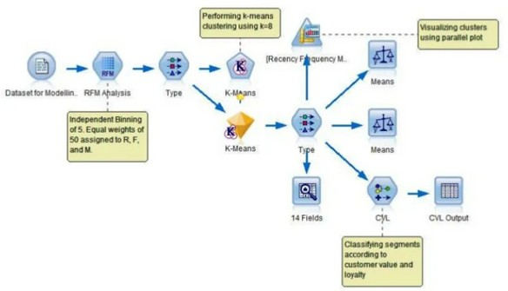

•

FIG: 5.1.3 SYSTEM ARCHITECTURE DIAGRAM

###### UML Diagrams

UML is a standard language for specifying, visualizing, constructing and documenting the Artifacts of software systems. The UML user mostly graphical notations to express the design of software project. It is a very important part of developing object- oriented software and the software development process. UML includes a set of graphic notation techniques to create visual models of object-oriented software-intensive

systems.

###### Use Case Diagrams

Use case diagrams are usually referred to as behavior diagrams used to describe a set of actions that some systems should or can perform in collaboration with one or more external users of the system (actors). Each use case should provide some observable and valuable result to the actors or other stakeholders of the system.

###### Table: 5.1.1A Graphical Representations of Use case Diagrams

|  |  |  |
| --- | --- | --- |
| Actor | An actor in the Unified Modelling Language specifies a role played by a user or any other system that interacts with the subject. |  |
| Use case | A Use Case is the functionality provided by the system. Use Cases are depicted with an ellipse. The name of the Use Case is written in ellipse. |  |
| Association | Association is a relationship between classifiers which is used to show that instances of classifiers could be either linked to each other or combined logically or physically into some aggregation. |  |

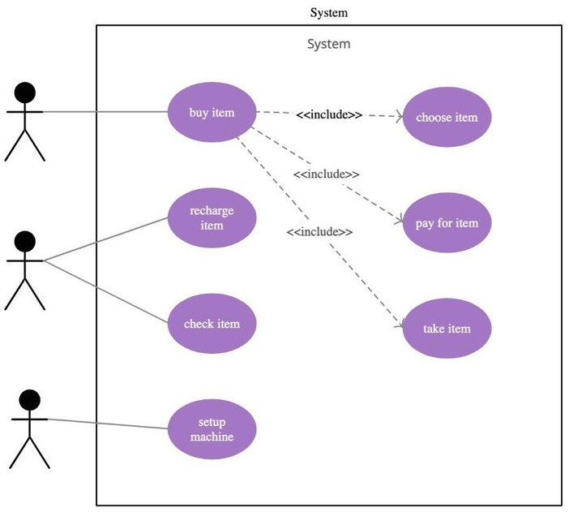

**Fig 5.1.1B Graphical Notation of Use Case Diagram**

pg. 31

###### Table: 5.1.2A Graphical Representations of Activity Diagrams

pg. 32

###### 5.1.3 CLASS DIAGRAM:

The Class diagram is a static diagram. It represents the static view of an application. The class diagram is not only used for visualizing, describing and documenting different aspects of a system but also for constructing executable code of the software application. It describes the attributes and operations of a class and the constraints imposed on the system. The class diagrams are widely used in the modelling of object-oriented systems because they areonly UML diagrams which can be mapped directly with object- oriented languages. The class diagram showsa collection of classes, interfaces, associations, collaborations and constraints. It is also known as a structural diagram.

###### Purpose

The purpose of the class diagram is to model the static view of an application. The class diagrams are only diagrams which can be directly mapped with object-oriented languages and thus widely used at the time of construction. UML diagrams like activity diagram, sequence diagram can only give the sequence flow of the application, but class diagram is a bit different. So, it is the most popular UML diagram in the coder community. So, the purpose of the class diagram can be summarized as:

* Analysis and design of the static view of an application.
* Describe the responsibilities of a system.
* Based on component and deployment diagrams.
* Forward and reverse engineering.

###### Active Class

Active classes initiate and control the flow of activity, while passive classes store data and serve other classes. Illustrate active classes with a thicker border.

###### Visibility

Use visibility markers to signify who can access the information which is in a class. Private visibility hides information from anything outside the class partition. Public visibility allows all other classes to view the marked information. Protected visibility allows child classes to access information which is inherited from a parent class.

###### Associations

Associations represent static relationship between the classes. Place the association names above, on or below the association line. Use a filled arrow to indicate the direction of the relationship. Place roles at the end of an association. Roles represent how the two classes see each other.

###### Multiplicity

Place multiplicity notations at the ends of an association. These symbols indicate the number of instances of one class linked to the instance of another class.

###### Constraint

Constraints are placed inside the curly braces {}.

###### Composition and Aggregation

Composition and aggregation link a semantic association between two classes in UML diagram. They are used in class diagrams. They both differ in their symbols.

###### Generalization

It is a specification relationship in which objects of the specialized element (the child) are substitutable for objects of the generalization element (the parent). It is used in class diagrams. In our class diagram classes are symptoms reader, symptoms Analyzer and Calculate vales. The responsibility of Symptoms reader is to read the symptoms from the patients. Symptoms Reader have the methods such as get Symptoms and add symptoms which are used to get the symptoms from the user and add to the training data set. Symptoms Analyzer can analyze the symptoms entered by the user and calculate vale class can calculate the accuracy values to predict the disease and suggest Specialist.

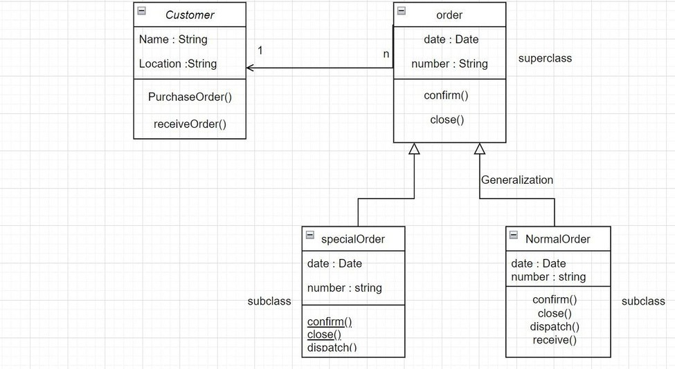

###### FIG: 5.1.3A CLASS DIAGRAM

* + 1. **COMPONENT DIAGRAM:**

A component diagram breaks down the actual system under development into various high levels of functionality. Each component is responsible for one clear aim within the entire system and only interacts with other essential elements on a need-to-know basis.

Basic Concepts of Component Diagram:

A component represents a modular part of a system that encapsulates its contents and whose manifestation is replaceable within its environment. In UML 2, a component is drawn as a rectangle with optional compartments stacked vertically. A high-level, ababstractiew of a component in UML 2 can be modelled as:

1. A rectangle with the component's name
2. A rectangle with the component icon
3. A rectangle with the stereotype text and/or icon



FIG: 5.1.3A COMPONENT DIAGRAM

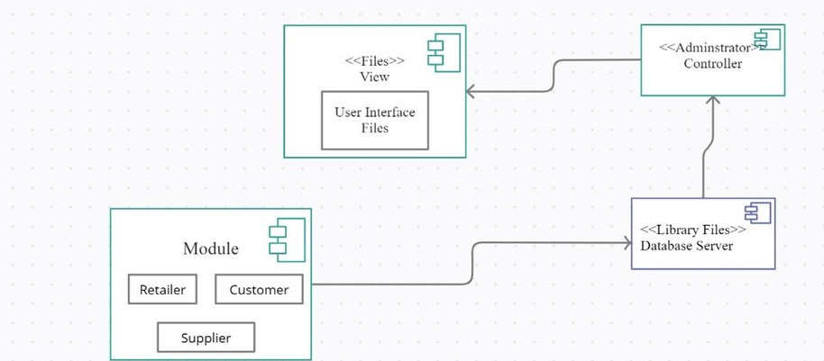

###### DEPLOYMENT DIAGRAM:

A deployment diagram is a UML diagram type that shows the execution architecture of a system, including nodes such as hardware or software execution environments, and the middleware connecting them. Deployment diagrams are typically used to visualize the physical hardware and software of a system. Using it you can understand how the system will be physically deployed on the hardware.

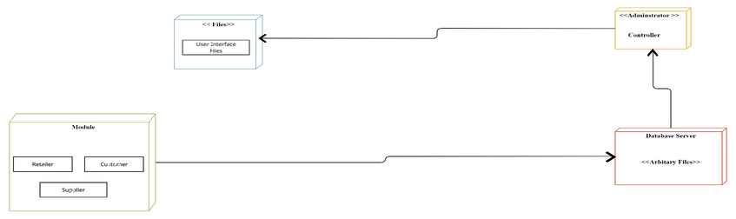Deployment diagrams help model the hardware topology of a system compared to other UML diagram types which mostly outline the logical components of a system.

**Deployment Diagram Notations FIG: 5.1.6 DEPLOYMENT DIAGRAM**

In order to draw a deployment diagram, you need to first become familiar with the following deployment diagram notations and deployment diagram elements.

**Nodes**

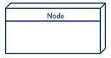A node, represented as a cube, is a physical entity that executes one or more components, subsystems or executables. A node could be a hardware or software element.

**Artifacts**

Artifacts are concrete elements that are caused by a development process. Examples of artifacts are libraries, archives, configuration files, executable files etc.

**Communication Association**

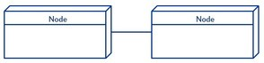This is represented by a solid line between two nodes. It shows the path of communication between nodes.

##### Devices

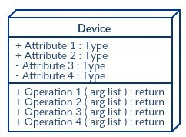A device is a node that is used to represent a physical computational resource in a system. An example of a device is an application server.

**CHAPTER 6**

**IMPLEMENTATION**

###### 6 . IMPLEMENTATION ALGORITHM DESCRIPTION

As customers use a subscription-based service they generate large amounts of structured data and metadata. From demographic data to usage and transaction data, it is relatively straightforward and efficient to collect and analyze even in a way which is privacy conscious. The idea underpinning this [approach is that customers on the verge of dropping exhibit certain common churn signals. These can be identified in the structured data and metadata that they generate through the use of their account.](https://www.bizdata.com.au/blogpost.php?p=real-time-vs-streaming-analytics) [Streaming data analytics](https://www.bizdata.com.au/blogpost.php?p=real-time-vs-streaming-analytics) systems are typically best suited to handling this level of real-time data.

**DECISION TREE ALGORITHM :**

A decision Tree is a that can be used for both classification and Regression problems, but mostly it is preferred for solving Classification problems. It is a tree-structured classifier, where internal nodes represent the features of a dataset, branches represent the decision rules and each leaf node represents the outcome. In a Decision tree, there are two nodes, which are the Decision Node and Leaf Node. Decision nodes are used to make any decision and have multiple branches, whereas Leaf nodes are the output of those decisions and do not contain any further branches. The decisions or the test are performed on the basis of features of the given dataset.

***It is a graphical representation for getting all the possible solutions to a problem/decision based on given conditions.***

###### Tree algorithm.

A decision tree simply asks a question, and based on the answer (Yes/No), it further split the tree into subtrees.

**K-MEANS ALGORITHM**

The algorithm takes the unlabeled dataset as input, divides the dataset into k-number of clusters, and repeats the process until it does not find the best clusters. The value of k should be predetermined in this algorithm.

The k-means [clustering](https://www.javatpoint.com/clustering-in-machine-learning) algorithm mainly performs two tasks:

Determines the best value for K center points or centroids by an iterative process. Assigns each data point to its closest k-center. Those data points which are near to the particular k-center, create a cluster.

The working of the K-Means algorithm is explained in the below steps:

Step-1: Select the number K to decide the number of clusters.

Step-2: Select random K points or centroids. (It can be other than the input dataset).

Step-3: Assign each data point to its closest centroid, which will form the predefined K clusters

Step-4: Calculate the variance and place a new centroid of each cluster.

Step-5: Repeat the third steps, which means reassign each datapoint to the new closest centroid of each cluster. Step-6: If any reassignment occurs, then go to step-4 else go to FINISH.

Step-7: The model is ready.

**Elbow Method**

The Elbow method is one of the most popular ways to find the optimal number of clusters. This method uses the concept of WCSS value. WCSS stands for Within Cluster Sum of Squares, which defines the total variations within a cluster. The formula to calculate the value of WCSS (for 3 clusters) is given below:

**WCSS= ∑Pi in Cluster1 distance(Pi C1)2 +∑Pi in Cluster2distance(Pi C2)2+∑Pi in CLuster3**

**distance(Pi C3)2**

.

###### SEMANTIC ANALYSIS

One [analysis](https://books.google.com.au/books?id=qDRyDwAAQBAJ&pg=PA156&lpg=PA156&dq=Customer%2BChurn%2BPrediction%2BUsing%2BSentiment%2BAnalysis%2Band%2BText%2BClassification%2Bof%2BVOC&source=bl&ots=32nG6MHTAl&sig=ACfU3U18cWhJS2cOVl4whlfsLsrgCUYPxA&hl=en&sa=X&ved=2ahUKEwiRwsKHhZXjAhUEUI8KHacQC64Q6AEwA3oECAkQAQ%23v%3Donepage&q&f=false) of these topics calls this space as the Voice of the Customer (VOC) and defines it as “call center calls, emails, questionnaires, web reviews and SMS”. It identifies that the existing research on this topic is still quite sparse and experimental, but highlights cases in which unstructured call center information applied to a churn prediction model led to an increase in its predictive power. This process is typically a statistical one. Yet, it is exploratory in nature. Many decisions made by the data analyst in the process of extracting market segments from consumer data affect the final market segmentation solution. For market segmentation analysis to be useful to an organisation, therefore, both a competent data analyst, and a user who understands the broader mission of the organisation (or that of their organisational unit when working in a team) need to be involved when market segments are extracted from consumer data. Throughout this book, we use the term user to mean the user of the segmentation analysis; the person or department in the organisation that will use the results from the market segmentation analysis to develop a marketing plan. To ensure that the grouping of consumers is of the highest quality, a number of additional tasks are required, as illustrated in the second layer in Fig. [2.1](https://link.springer.com/chapter/10.1007/978-981-10-8818-6_2#Fig1). All these tasks are still primarily technical in nature. Collecting good data, for example, is critically important. The statistical segment extraction process at the core of market segmentation analysis cannot compensate for bad data. The grouping of consumers can always only be as good as the data provided to the segment extraction method.Upon completion of data collection, but before the actual segment extraction takes place, the data needs to be explored to gain preliminary insight into the nature of the market segmentation study that can be conducted using this data. Finally, after consumers have been grouped into market segments, each of these segments needs to be profiled and described in detail. Profiling and describing segments help users to understand each of the segments, and select which one(s) to target. When one or more target segments have been chosen, profiling and describing segments inform the development of the customised marketing mix.If all the tasks in the first (core) and second layer of market segmentation analysis have been implemented well, the result is a theoretically excellent market segmentation solution. But a theoretically excellent market segmentation solution is meaningless unless users can convert such a solution into strategic marketing decisions and tactical marketing action. Therefore, for any market segmentation analysis to be complete, a third layer is required.

This third layer includes non-technical tasks. These tasks represent organisational implementation issues, and do not sequentially follow the first and the second layer. As illustrated in Fig. [2.1](https://link.springer.com/chapter/10.1007/978-981-10-8818-6_2#Fig1), the third layer of implementation tasks wraps around technical tasks.

Before any technical tasks are undertaken, an organisation needs to assess whether, in their particular case, implementing a market segmentation strategy will lead to market opportunities otherwise unavailable to them. If the market segmentation analysis points to such opportunities, the organisation must be willing to commit to this long-term strategy. All of these decisions have to be made by the users and are entirely independent of the technical task of extracting market segments from data. User input is also critically important at the data collection stage to ensure that relevant information about consumers will be captured. Again, this is not a decision a data analyst can make.

Upon completion of the segment extraction task, users need to assess resulting market segments or market segmentation solutions and select one or more target segments. Data analysts can provide facts about these segments, but cannot select the most suitable ones. This selection is driven, in part, by the strengths and opportunities of the organisation, and their alignment with the key needs of the market segments. Finally, as soon as one or more target segments have been selected, users need to develop a marketing plan for those market segments, and design a customised marketing mix.

**Optimising the model**

If K is too small the model will be “overfit”. This means that the model will do well on the data you used to create it, but when it comes across new observations it will perform poorly. If K is too high,

the model will also perform poorly. The best value of K was selected by picking one that is not to

high or low.

**Variable Selection**

Not all variable are useful in predicting if a customer will churn. For example, the customers phone number is completely useless in predicting because it is unique to each customer.

* 1. **Technology Description**

Python is an interpreted high-level general-purpose programming language. Python's design philosophy emphasizes code readability with its notable use of significant indentation. Its language constructs as well as its object-oriented approach aim to help programmers write clear, logical code for small and large-scale projects. Python is dynamically typed and garbage- collected. It supports multiple programming paradigms, including structured (particularly, procedural), object-oriented and functional programming. Python is often described as a "batteries included" language due to its comprehensive standard library.

### JUPYTER

Jupyter Notebooks are a spin-off project from the IPython project, which used to have an IPython Notebook project itself. The name, Jupyter, comes from the core supported programming languages that it supports: Julia, Python, and R. Jupyter ships with the IPython kernel, which allows you to write your programs in Python, but there are currently over 100 other kernels that you can also use.

While there are many ways to use Jupyter Notebook depending on your goals and intentions, the first step in using the notebook is getting to know the technology. One of the best parts of using Jupyter Notebook is

pg. 43

its flexibility and versatility, as you can work with the technology by downloading [JupyterLab,](https://blog.jupyter.org/jupyterlab-is-ready-for-users-5a6f039b8906) or simply opening your browser to use the notebook on the go through the original application. A tool that was made for collaboration and interactivity, Jupyter Notebook is also compatible with the most commonly used programming languages such as R, C++, Ruby, and Python.

Jupyter Notebook also gives the user access to a community of fellow users and open-source programming libraries. Once you begin using it, it is easy to find additional information and instructions on how to use the technology and integrate it into other components that may interest you. Divided into front end and back end interfaces, Jupyter Notebook not only gives users access to the outcome of their code but also assists in the process of tweaking and editing the code before it is executed. This list outlines the top

five uses for the Jupyter Notebook both within and outside of the classroom.

* + 1. **HTML**

HTML stands for Hyper Text Mark-up Language. It is used to design web pages using a mark- up language. HTML is the combination of Hypertext and Mark-up language. Hypertext defines the link between the web pages. A mark-up language is used to define the text document within tag which defines the structure of web pages.

HTML is a mark-up language that is used by the browser to manipulate text, images, and other content to display it in the required format.

pg. 44

###### JAVA SCRIPT

Java script is the most popular programming language in the world and that makes it a programmer’s great choice. Once you learnt Java script, it helps you developing great front- end as well as back-end software’s using different Java script-based frameworks like j Query, Node.JS etc.

###### CSS

Cascading Style Sheets, fondly referred to as CSS, is a simple design language intended to simplify the process of making web pages presentable.

CSS is a MUST for students and working professionals to become a great Software Engineer

specially when they are working in Web Development Domain.

###### J QUERY

J Query is a fast and concise JavaScript library created by John Resign in 2006. jQuery simplifies HTML document traversing, event handling, animating, and Ajax interactions for Rapid Web Development.

###### FLASK

Flask is a web framework, it’s a Python module that lets you develop web applications easily. It has a small and easy-to-extend core: it’s a microframework that doesn’t include an ORM (Object Relational Manager) or such features.It does have many cool features like url routing, template engine. It is a WSGI web app framework.

Flask is a web application framework written in Python. It was developed by Armin Ronacher, who led a team of international Python enthusiasts called Poocco. Flask is based on the Werkzeg WSGI toolkit and the Jinja2 template engine.Both are Pocco projects.

###### MARKET SEGMENTATION ANALYSIS

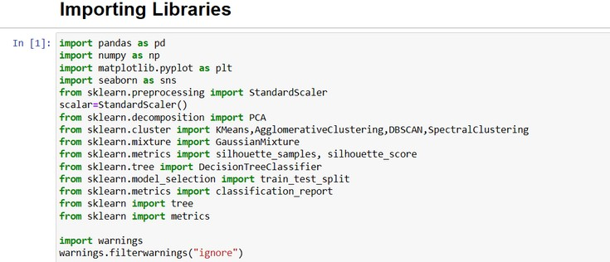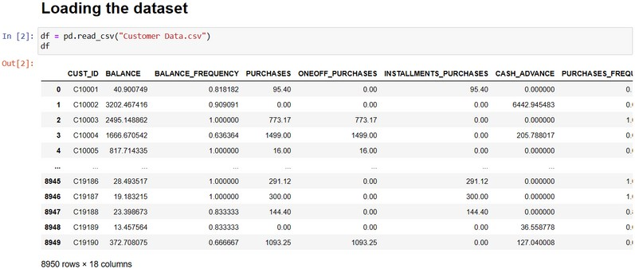

**EXPLORATORY DATA ANALYSIS**

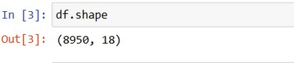

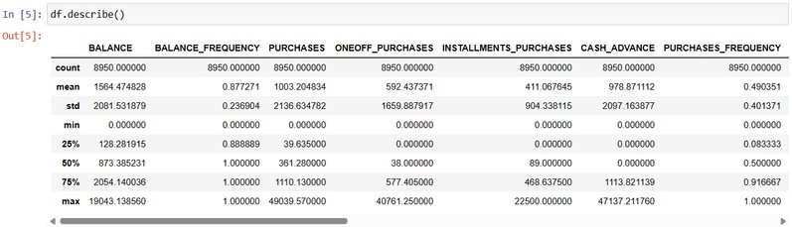

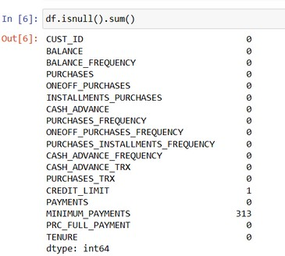

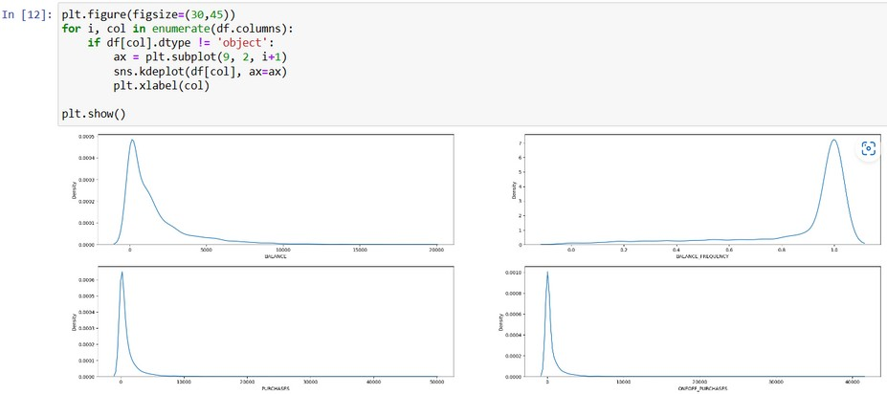

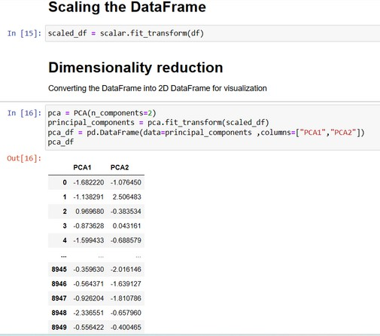

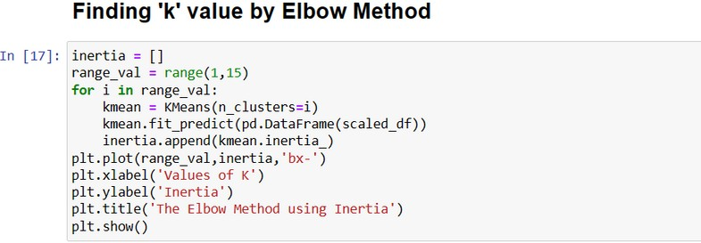

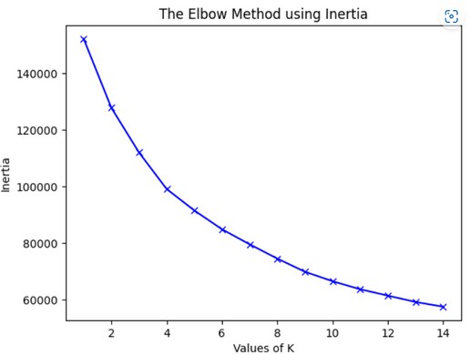

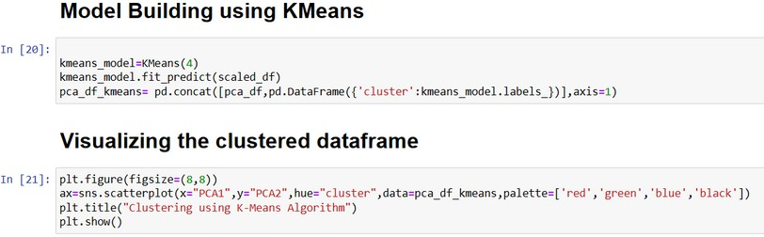

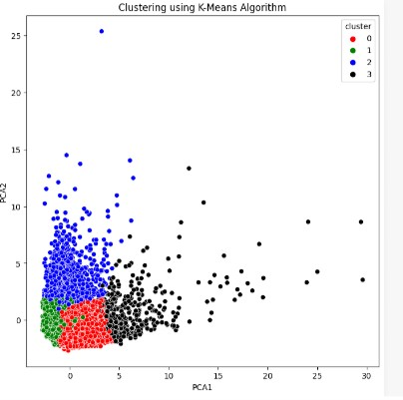

**INSIGHTS GATHERING DERIVED INSIGHTS**

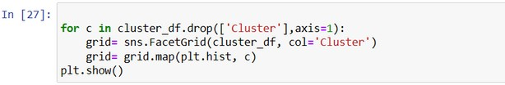

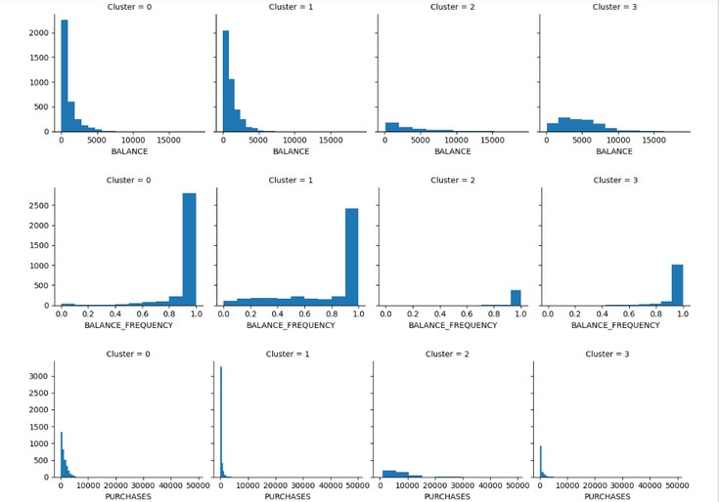

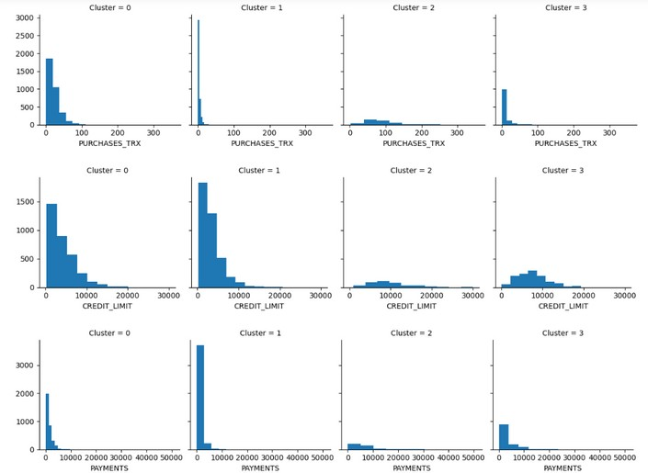

* 1. **Sample Source Code:**

from sklearn import preprocessing import streamlit as st

import pandas as pd

import plotly.figure_factory as ff import matplotlib.pyplot as plt import seaborn as sns

import pickle

filename = 'final_model.sav'

loaded_model = pickle.load(open(filename, 'rb')) df = pd.read_csv("Clustered_Customer_Data.csv")

st.set_option('deprecation.showPyplotGlobalUse', False) st.markdown('<style>body{background-color: Blue;}</style>',unsafe_allow_html=True) st.title("Prediction")

with st.form("my_form"):

balance=st.number_input(label='Balance',step=0.001,format="%.6f") balance_frequency=st.number_input(label='Balance Frequency',step=0.001,format="%.6f") purchases=st.number_input(label='Purchases',step=0.01,format="%.2f") oneoff_purchases=st.number_input(label='OneOff_Purchases',step=0.01,format="%.2f") installments_purchases=st.number_input(label='Installments Purchases',step=0.01,format="%.2f")

cash_advance=st.number_input(label='Cash Advance',step=0.01,format="%.6f") purchases_frequency=st.number_input(label='Purchases Frequency',step=0.01,format="%.6f") oneoff_purchases_frequency=st.number_input(label='OneOff Purchases Frequency',step=0.1,format="%.6f") purchases_installment_frequency=st.number_input(label='Purchases Installments Freqency',step=0.1,format="%.6f")

cash_advance_frequency=st.number_input(label='Cash Advance Frequency',step=0.1,format="%.6f") cash_advance_trx=st.number_input(label='Cash Advance Trx',step=1) purchases_trx=st.number_input(label='Purchases TRX',step=1) credit_limit=st.number_input(label='Credit Limit',step=0.1,format="%.1f") payments=st.number_input(label='Payments',step=0.01,format="%.6f")

minimum_payments=st.number_input(label='Minimum Payments',step=0.01,format="%.6f")

prc_full_payment=st.number_input(label='PRC Full Payment',step=0.01,format="%.6f") tenure=st.number_input(label='Tenure',step=1)

data= [[balance,balance_frequency,purchases,oneoff_purchases,installments_purchases,cash_advanc e,purchases_frequency,oneoff_purchases_frequency,purchases_installment_frequency,cash_ad vance_frequency,cash_advance_trx,purchases_trx,credit_limit,payments,minimum_payments, prc_full_payment,tenure]]

submitted = st.form_submit_button("Submit") if submitted:

clust=loaded_model.predict(data)[0] print('Data Belongs to Cluster',clust) cluster_df1=df[df['Cluster']==clust] plt.rcParams["figure.figsize"] = (20,3)

for c in cluster_df1.drop(['Cluster'],axis=1): fig, ax = plt.subplots()

grid= sns.FacetGrid(cluster_df1, col='Cluster')

grid= grid.map(plt.hist, c) plt.show() st.pyplot(figsize=(5, 5))

CHAPTER 7

TESTING

pg. 53

* 1. TESTING
     1. Introduction

Software testing is an investigation conducted to provide stakeholders with information about the quality of the product or service under test. Software testing can also provide an objective, independent view of the software to allow the business to appreciate and understand the risks of software implementation. Test techniques include, but are not limited to, the process of executing a program or application with the intent of finding software bugs (errors or other defects).

Testing involves the execution of a software component or system component to evaluate one or more properties of interest. In general, these properties indicate the extent to which the component or system under test have the following

* + - Meets the requirements that guided its design and development
    - Responds correctly to all kinds of inputs
    - Performs its functions within an acceptable time

•

Is sufficiently usable

•

Can be installed and run in its intended environments and achieves the general result

its stake Holders desire.

As the number of possible tests for even simple software components is practically infinite, all software testing uses some strategy to select tests that are feasible for the available time and resources. As a result, software testing typically (but not exclusively) attempts to execute a program or application with the intent of finding software bugs (errors or other defects).

Software testing can provide objective, independent information about the quality of software and risk of its failure to users and/or sponsors.

Software testing can be conducted as soon as executable software (even if partially complete) exists. The overall approach to software development often determines when and how testing is conducted. For example, in a phased process, most testing occurs after system requirements have been defined and then implemented in testable

programs. In contrast, under an Agile approach, requirements, programming, and testing are often done concurrently.

Testing Types

A software engineering product can be tested in one of two ways:

* + - * Black Box Testing
      * White Box Testing

Black box testing

Knowing the specified function that a product has been designed to perform, determine whether each function is fully operational.

White box testing

Knowing the internal workings of a software product determine whether the internal operation implementing the functions perform according to the specification, and all the internal components have been adequately exercised.

Testing Strategies

Four Testing Strategies that are often adopted by the software development team include:

Testing Strategies Four Testing Strategies that are often adopted by the software development team include:

* Unit Testing
* Integration
* Testing Validation
* Testing System Testing

Unit Testing

We adopt white box testing when using this testing technique. This testing was carried out on individual components of the software that were designed. Each individual module was tested using this technique during the coding phase. Every component was checked to make sure that they adhere strictly to the specifications spelt out in the data flow diagram and ensure that they perform the purpose intended for them.

All the names of the variables are scrutinized to make sure that they are truly reflected of the element they represent. All the looping mechanisms were verified to ensure that they were as decided. Beside these, we trace through the code manually to capture syntax errors and logical errors.

Integration Testing

After finishing the Unit Testing process, next is the integration testing process. In this testing process we put our focus on identifying the interfaces between components and their functionality as dictated by the DFD diagram. The Bottom-up incremental approach was adopted during this testing. Low level modules are integrated and combined as a cluster before testing.

The Black box testing technique was employed here. The interfaces between the components were tested first. This allowed identifying any wrong linkages or parameters passing early in the development process as it just can be passed in a set of data and

checked if

the result returned is an accepted one.

Validation Testing

The system has been tested and implemented successfully and thus ensured that all the requirements listed in the software requirements specification are completely fulfilled. In

case

of erroneous input corresponding error messages are displayed.

System Testing

System testing is a series of different tests whose primary purpose is to fully exercise the computer-based system. Although each test has a different purpose, all the work should verify that all system elements have been properly integrated and perform allocated functions. System testing also ensures that the project works well in the environment. It traps the errors and allows convenient processing of errors without coming out of the program abruptly.

Software testing is critical element of software quality assurance and represents ultimate review of specification, design and coding. Test case design focuses on a set of technique for the creation of test cases that meet overall testing objectives. Planning and testing of a programming system involve formulating a set of test cases, which are similar to the real data that the system is intended to manipulate. Test castes consist of input specifications, a description of the system functions exercised by the input and a statement of the extended output.

In principle, testing of a program must be extensive. Every statement in the program should be exercised and every possible path combination through the program should be executed at least once. Thus, it is necessary to select a subset of the possible test cases and conjecture that this subset will adequately test the program.

TESTING CHURN RATE

:

To calculate churn rate, choose a time period, such as monthly or annual. You’ll need to know the number of customers you had at the beginning of the time period and the number you lost. Divide the following: Lost Customers ÷ Total Customers at the Start of Time Period. Then, multiply the number by 100.

Remember, the steps to calculate churn rate are:

* Determine a time period: monthly, annual, or quarterly.
* Determine the number of customers you had at the beginning of the time period.
* Determine the number of customers that churned by the end of the time period.
* Divide the number of lost customers by the number of customers you had prior to the

Customer Churn Rate = (Lost Customers ÷ Total Customers at the Start of Time Period) x 100 churn. • Multiply that number by 100.

*Customer Churn Rate = (50 ÷ 500) x 100 Customer Churn Rate = (0.10) x 100 Customer Churn Rate = 10%*

Guidelines for developing test cases

* + Describe which feature or service your test attempts to cover
  + If the test case is based on a use case, it is a good idea to refer to the use case name.
  + Remember that the use cases are the source of test cases. In theory the software is supposed to match the use cases not the reverse. As soon as you have enough use cases
  + , go ahead and write the test plan for that piece

Specify what you are testing and which particular feature. Then specify what you

* + are

going to do to test the feature and what you expect to happen.

•

Test the normal use of the object’s methods. Test the abnormal but reasonable

•

use of

the object’s methods.

•

Test the abnormal but unreasonable use of the object’s methods.

Test the boundary conditions. Also specify when you expect error dialog boxes,

•

when

you expect some default event, and when functionality till is being defined. Test object’s interactions and the messages sent among them. If you have developed

sequence diagrams, they can assist you in this process

when the revisions have been made, document the cases so they become the starting

bases for the follow- up test

Attempting to reach agreement on answers generally will raise other what-if questions. Add these to the list and answer them, repeat the process until the list is stabilized, then you need not add any more questions.

Table: 7.2 Representation of Test cases and status

TEST CASE1 :

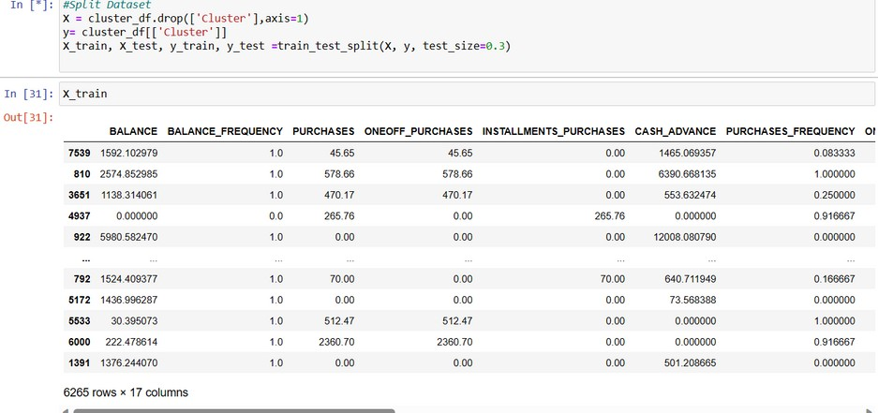

TEST CASE 2:

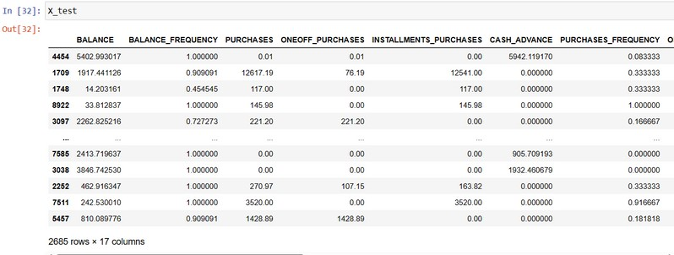

pg. 60

Test Case 3:

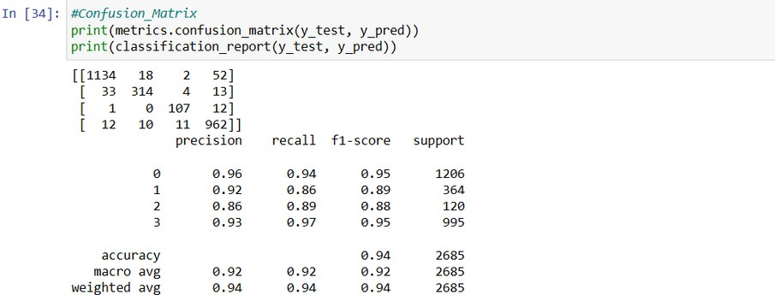

Final Output

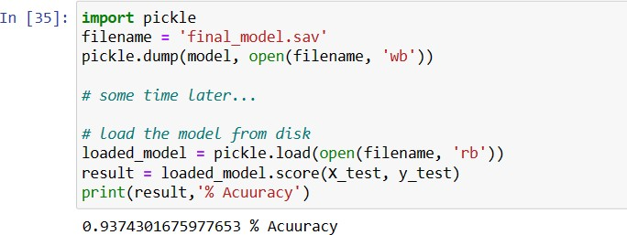

pg. 61

CHAPTER 8

RESULTS

pg. 62

* 1. RESULTS

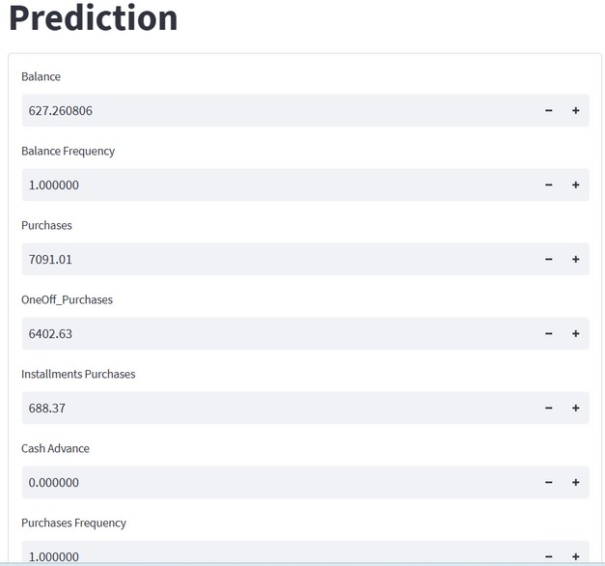

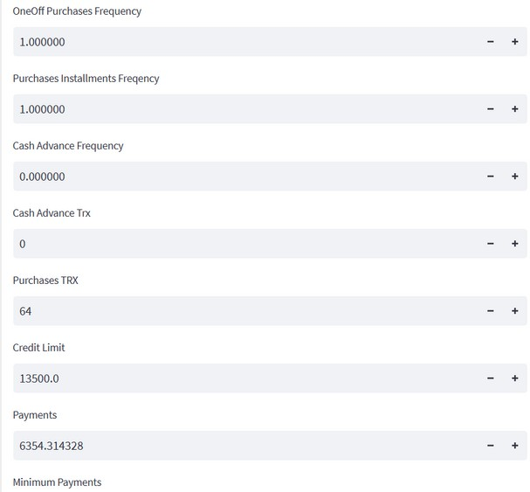

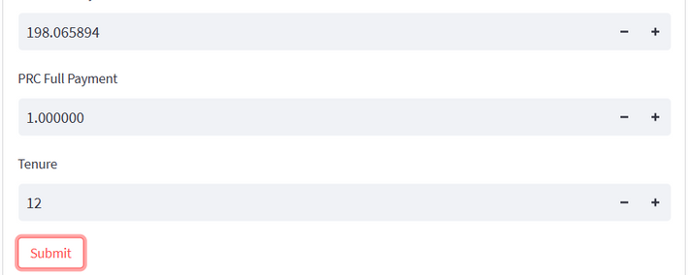

###### Final Result

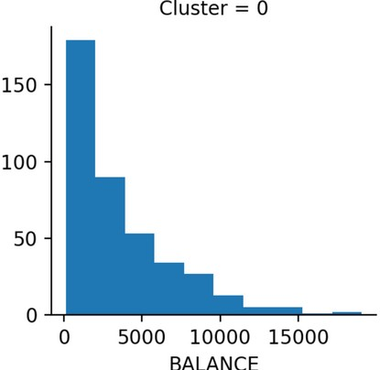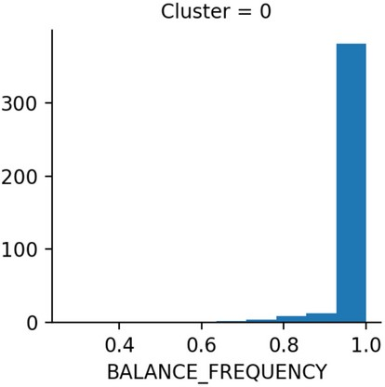

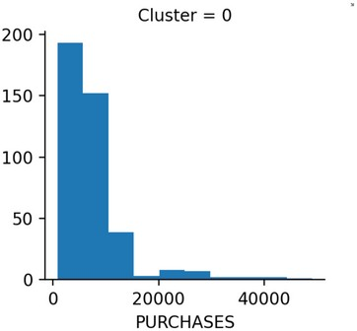

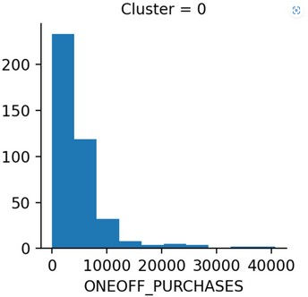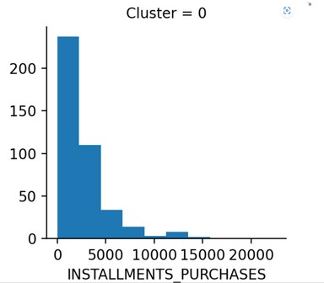

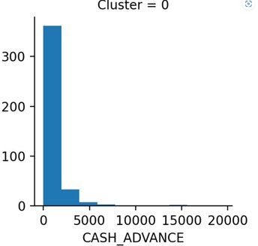

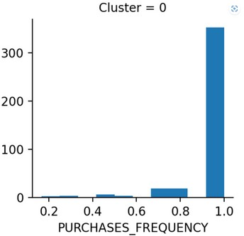

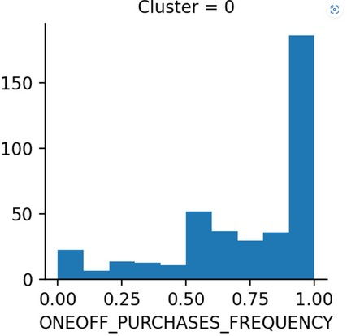

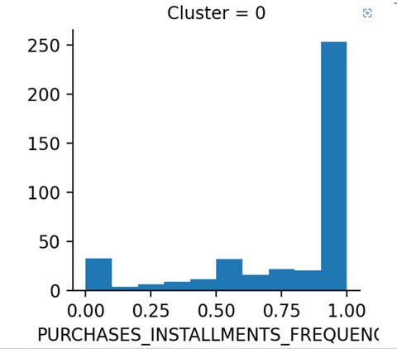

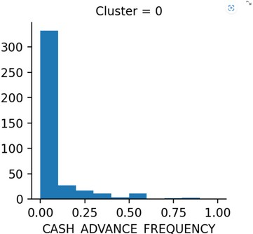

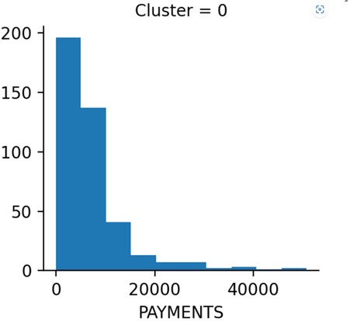

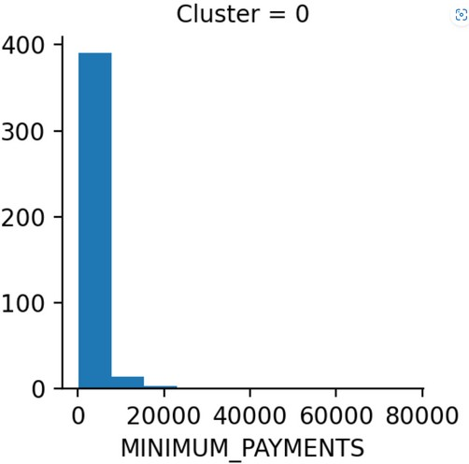

pg.67

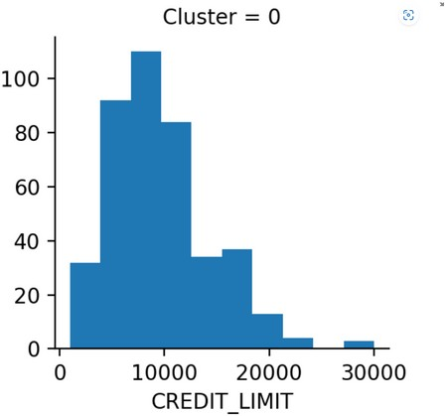

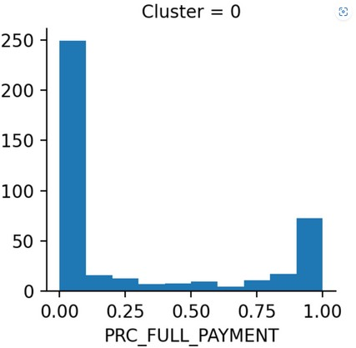

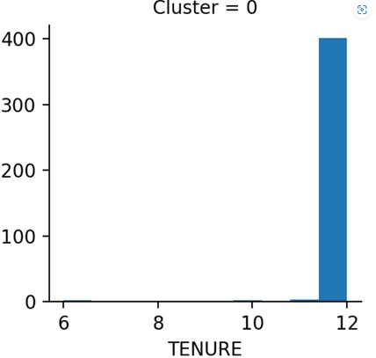pg.68

CHAPTER 9

# CONCLUSION

## pg. 69

* 1. CONCLUSION

Using market segmentation, companies are able to identify their target audiences and personalize marketing campaigns more effectively. This is why market segmentation is key to staying competitive. It allows you to understand your customers, anticipate their needs, and seize growth opportunities. This powerful technique allows you to improve your decision-making, marketing efforts, and improve your company’s bottom line.

The key to successful market segmentation remains data quality; therefore, you need to pick your data provider after doing your [due diligence](https://coresignal.com/blog/ma-due-diligence/), ensuring that you have access to the latest industry information in accessible and easy-to-understand formats.

Market segmentation results in more effective and efficient marketing, advertising and sales. Rather than targeting a broad audience with generic messaging and offers, market segmentation enables brands to [provide offers specifically tailored](https://www.techtarget.com/searchcustomerexperience/tip/4-tips-for-creating-a-personalized-marketing-strategy) to each segment's needs.

Consider an advertising campaign organized around a particular market segment. A brand can select relevant targeting criteria to reach users who fit the criteria of that market segment.

Market segmentation can result in a campaign that is both effective and efficient: Audience segmenting and customized messaging drives higher success rates, while advertising dollars are only spent to reach the defined audience. The same non-segmented campaign would suffer from lower response rates, with a portion of the advertising budget wasted on the wrong audience. The purpose of market segmentation is to group customers with similar attributes together so that businesses and brands can understand their wants, needs, and behaviors so that they can ultimately market to the segments that make the most profit.

Program Outcomes:

|  |  |  |  |  |  |  |  |  |  |  |  |
| --- | --- | --- | --- | --- | --- | --- | --- | --- | --- | --- | --- |
| PO1 | PO2 | PO3 | PO4 | PO5 | PO6 | PO7 | PO8 | PO9 | PO10 | PO11 | PO12 |
| 3 | 3 | 3 | 2 | 2 | 2 | 2 | 2 | 3 | 1 | 1 | 2 |

Program Specific Outcomes:

|  |  |  |
| --- | --- | --- |
| PSO1 | PSO2 | PSO3 |
| 3 | 2 | 1 |

pg. 70

CHAPTER 10

# REFERENCES

pg. 71

### REFERENCES

1. *Anon. (1990), ‘Ad Agency Finds 5 Global Segments’, Marketing News 8 (January), pp. 9–17.*
2. *Bleda, J. C. and Kassarjian, H. H. (1969), ‘An Overview of Market Segmentation’, in Morin, B. A. (ed.), Marketing in a Changing World, Chicago: American Marketing Association, pp. 249–253.*
3. *Coleman, R. P. (1961), ‘The Significance of Social Stratification in Selling’, Marketing: A Maturing Discipline, ed. M. L. Bell, Chicago: American Marketing Association, pp. 171– 184.*
4. *Craven, D., Hills, G. and Woodruff, R. (1987), Marketing Management, Homewood, Ill.: Richard D. Irwin, pp. 297–300.*
5. *Craven, D., Hills, G. and Woodruff, R. (1987), Marketing Management, Homewood, Ill.: Richard D. Irwin, pp. 297–300.*
6. *Green, P. E. and Kreiger, A. M. (1991), ‘Segmenting Markets with Conjoint Analysis’, Journal of Marketing (October), pp. 20–31.*
7. *Haley, R. J. (1968), ‘Benefit Segmentation: A Decision Oriented Research Tool’, Journal of Marketing (July), pp. 30–35.*
8. *Piercy, N. F. and Morgan, N. A. (1993), ‘Strategic and Operational Market Segmentation: A Managerial Analysis’, Journal of Strategic Marketing 1, pp. 123–140.*

#### pg. 72